# TOPS TECHNOLOGIES ASSIGNMENT

**MODULE :1**

1. **What is software? What is software engineering?**

**🡪**Software refers to the set of instructions, data, or programs that tell a computer how to perform specific tasks. It can be categorized into two main types:

1. System Software: This includes the operating system and utility programs that manage computer hardware and provide a platform for application software.
2. Application Software: These are programs designed for end-users to perform specific tasks, like word processing, web browsing, or graphic design.

Software Engineering is the systematic application of engineering principles to the design, development, maintenance, testing, and evaluation of software. It involves:

* Requirements Analysis: Understanding what the software needs to accomplish.
* Design: Creating a blueprint for how the software will work.
* Implementation: Writing the actual code.
* Testing: Ensuring the software functions as intended and is free of defects.
* Maintenance: Updating and fixing software after it has been deployed.

1. **Explain types of software?**

**🡪**System Software

* Operating Systems (OS): Manage hardware and software resources (e.g., Windows, macOS, Linux).
* Utility Software: Perform maintenance tasks (e.g., antivirus programs, disk management tools).

2. Application Software

* Productivity Software: Helps users perform tasks (e.g., Microsoft Office, Google Docs).
* Graphics Software: Used for creating and editing images (e.g., Adobe Photoshop, CorelDRAW).
* Web Browsers: Enable access to the internet (e.g., Chrome, Firefox).
* Database Software: Manage and organize data (e.g., MySQL, Oracle).
* Communication Software: Facilitate communication (e.g., Slack, Zoom).

3. Development Software

* Programming Languages: Tools for writing code (e.g., Python, Java, C++).
* Integrated Development Environments (IDEs): Provide comprehensive facilities for software development (e.g., Visual Studio, Eclipse).
* Version Control Systems: Track changes in code (e.g., Git, SVN).

4. Middleware

* Software that connects different applications or services, allowing them to communicate (e.g., message brokers, database middleware).

5. Embedded Software

* Software specifically designed to operate hardware (e.g., firmware in appliances, automotive software).

6. Open Source Software

* Software with source code that can be freely used, modified, and distributed (e.g., Linux, Apache).

7. Proprietary Software

* Software that is owned by an individual or company and typically requires purchase or licensing (e.g., Microsoft Office, Adobe Creative Suite).

8. Freeware and Shareware

* Freeware: Software available for free but may have restrictions (e.g., Adobe Acrobat Reader).
* Shareware: Software distributed for free on a trial basis, often with limited features (e.g., WinRAR).

9. Mobile Apps

* Applications specifically designed for mobile devices (e.g., Instagram, mobile banking apps).

10. Cloud-Based Software

* Applications hosted on the cloud and accessed via the internet (e.g., Google Drive, Salesforce).

Each type of software plays a crucial role in the computing ecosystem, catering to various user needs and technological requirements.

1. **What is SDLC ? Explain each phase of SDLC.**

* The **Software Development Life Cycle (SDLC)** is a structured process used for developing software applications. It consists of several phases, each designed to ensure the successful delivery of high-quality software. Here’s a breakdown of each phase:

**1. Planning**

**Purpose**: Define the scope, objectives, and feasibility of the project.

**Activities**: Gather initial requirements, assess resources, create a project timeline, and establish budgets. Stakeholders are identified, and risks are analyzed.

**2. Requirements Analysis**

**Purpose**: Gather and document the requirements for the software.

**Activities**: Engage with stakeholders to understand their needs. Create detailed specifications that outline functional and non-functional requirements. This phase ensures all parties agree on what the software should do.

**3. Design**

**Purpose**: Create the architecture and design specifications for the software.

**Activities**: Develop high-level and detailed designs, including system architecture, user interfaces, database design, and module specifications. This phase serves as a blueprint for development.

**4. Implementation (Coding)**

**Purpose**: Translate design specifications into actual code.

**Activities**: Developers write code based on the design documents. This phase may involve integrating third-party services and libraries. Code reviews and adherence to coding standards are crucial.

**5. Testing**

**Purpose**: Identify and fix defects before deployment.

**Activities**: Conduct various testing types, including unit testing, integration testing, system testing, and user acceptance testing (UAT). This phase ensures the software meets the specified requirements and is free of significant bugs.

**6. Deployment**

**Purpose**: Release the software to users.

**Activities**: Install the software in the production environment. This may involve setting up servers, configuring databases, and ensuring all components work together. Training may also be provided to users.

**7. Maintenance**

**Purpose**: Address issues and improve the software after deployment.

**Activities**: Monitor the software for defects, implement updates, and add new features based on user feedback. Regular maintenance ensures the software remains functional and relevant.

1. **What is DFD ? Create a DFD of flipkart.**

* **Data Flow Diagram (DFD)** is a visual representation used to illustrate how data moves through a system. It shows the flow of data between processes, data stores, and external entities. DFDs help in understanding the functionality of a system, analyzing processes, and identifying potential improvements.

s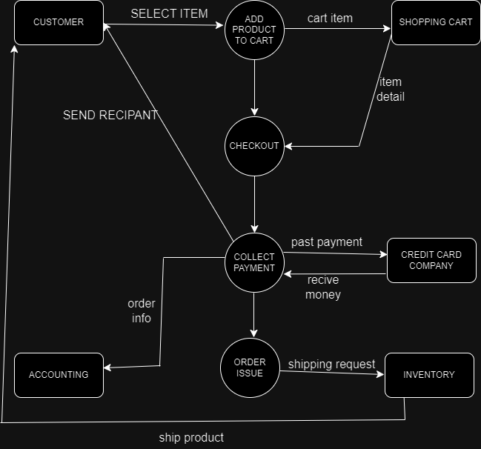

1. **what is flowchart? Create a flow chart to make a decission of tow numbers ?**

🡪 A flow chart is a visual representation of a process or workflow. It uses standardized symbols, such as ovals, rectangles, diamonds, and arrows, to illustrate the steps involved and the sequence of actions. Flow charts help simplify complex processes, making it easier to understand, analyze, and communicate how a task is completed or how information flows within a system. They're commonly used in various fields, including business, engineering, and education, to enhance clarity and efficiency.

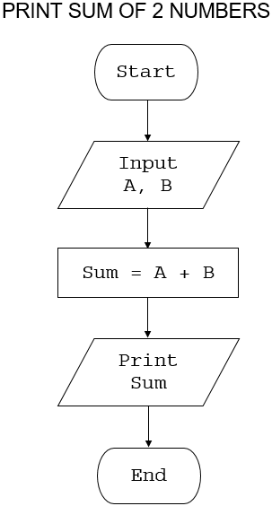

1. **what is use case diagram?Create a use-case diagram on billpayment on paytm?**

**🡪**A use case diagram is a type of visual representation used in software engineering to illustrate the interactions between users (or "actors") and a system. It focuses on the functional requirements of the system by depicting various use cases—specific scenarios in which the system is utilized.

